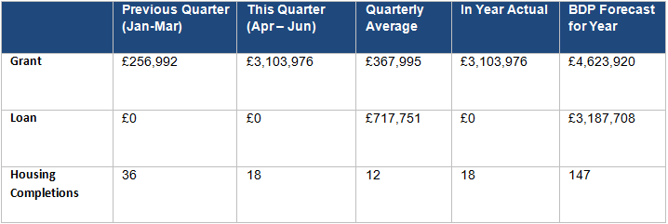
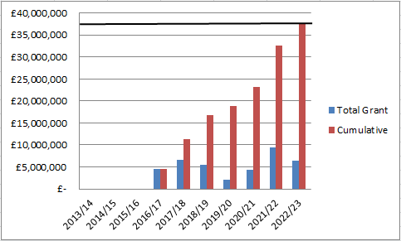
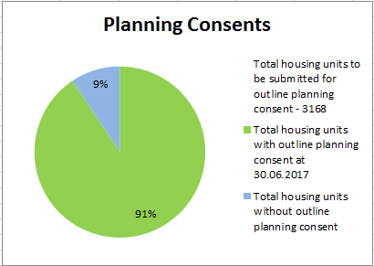
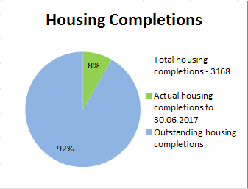
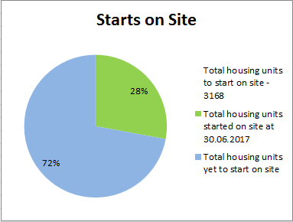
No additional planning permission secured in this reporting period.

Only Pickerings Farm is yet to achieve planning, however an amended planning consent for remaining Whittingham phases is required.
Development is underway on five outlets. There has been a slight increase in housing completions to reflect the increased development activity on Eastway and Croston Road South.
No additional Starts on Site during this reporting period

Starts on Site are counted for the entire site on commencement of first unit.

£3,103,976 of grant paid in this reporting period. The grant was so high this quarter due to a committed payment of almost £2.5m being made by Miller and paid back out to LCC. In addition to this a balancing sum of almost £600k for Cottam Ph1’s Guaranteed Annual Payment was made this quarter
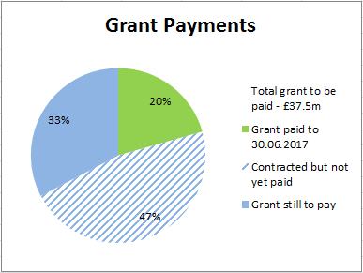

1.0 Report Overview

  - This report provides an update on the progress made by the HCA on the delivery of the City Deal housing sites from 01.04.17 to 30.06.17. It focuses on the key delivery milestones, finances invested, outputs and draws out key risks and emerging issues.

  - The report format has been changed to provide a more visual snapshot of progress and enable comparison on a quarter by quarter basis.

2.0 Recommendation

  - The Stewardship Board and Executive are recommended to:

    - Note the content of the report and the progress made

- HCA Site Highlights (01.04.17 to 30.06.17)

  - Between the period 01.04.17 and 30.06.17, progress has been made on a number of HCA sites. Key highlights and future milestones can be found in the table below:

Site | Project | Status | Completions/total units | Completions (Apr-Jun) | Finance  (Apr-Jun) | Summary | Milestones for next quarter (Jul-Sep)
1 | Cottam Hall Phase 1 (Site K) | Barratts on site | 68/104 (65%) | TBC | £648,326 grant paid to LCC in this reporting period | The grant consisted of payments from 2 plot sales, as well as the remainder of the Guaranteed Annual Payment.  Since the end of the reporting period a further £148,510 has been paid in grant to LCC. | Further grant payments are anticipated however the amounts are dependent on plot sales.
 | Cottam Hall Phase 2 | Story Homes on site. | 28/283 (10%) | 6 | N/A | 2 completions since the end of the reporting period. | N/A – ongoing build out
 | Cottam Hall Phase 3 | Deal done with Morris Homes - not yet on site. RM application submitted. | 0/119 (0%) | N/A | N/A | RM application was submitted in March 2017. | RM application to be considered at September’s planning committee. This should enable the deal to go unconditional and trigger the loan payment (£3m)
2 | Cottam Brickworks | Planning permission in place | 0/206 (0%) | N/A | N/A | Site in 3rd party ownership. Access land agreement has lapsed | No progress envisaged by land owner in forthcoming quarter.
3 | Land at Eastway (resi) | Story Homes on site. | 16/300 (5%) | 9 | N/A | There have been a further 3 completions since the end of the reporting period.  There has been a loan repayment of £1.17m from City Deal and a grant payment of £2.28m since the end of the reporting period. | LCC will repay the loan payment of c£1.17m. A grant payment of £2.28m will be made to LCC following a further contractual payment from the developer.
 | Land at Eastway (commercial) | Deal done with HBS Healthcare Ltd – not yet on site. | N/A (commercial) | N/A | N/A | The site was sold to HBS Healthcare Ltd in May on a conditional basis – the condition is that Story Homes construct the access to the site. | N/A
4 | Whittingham | Taylor Wimpey on site (phase 1 only) | Ph 1 - 56/150 (37%) | 11 | N/A | Consultant procurement to resolve planning and design issues to commence shortly. | N/A – ongoing build
5 | Preston East EA | Site not yet marketed | N/A (commercial) | N/A | N/A | Feasibility work being undertaken by consultants. | Soft market testing report being undertaken by JLL to be received by HCA.
 | Preston East – Sector D | Deal done with Inchcape Estates – not yet on site | N/A | N/A | N/A | No further updates as the sale was an unconditional freehold disposal. | N/A
6 | Pickerings Farm | Site not yet marketed | 0/297 (0%) | N/A | N/A | Negotiations with Taylor Wimpey re collaboration agreement ongoing. | N/A
7 | Altcar Lane | Site currently on the market | 0/200 (0%) | N/A | N/A | Following marketing, 11 expressions of interest received. 6 responses to the sifting brief and 4 of these were shortlisted. ITT issued to the 4 shortlisted parties. Tender process has been put back a month due to policy changes. Tender returns now due 1 November 2017 | N/A
8 | Croston Road North | Site not yet marketed | 0/400 (0%) | N/A | N/A | Clarity over the delivery of the spine road requirement before marketing commences. | N/A
9 | Croston Road South | Miller on site. | 31/175 (18%) | 18 | £585,210 loan repaid in April. First grant payment of almost £2.5m was paid to LCC. | Millers on site and building out. | N/A – ongoing build
10 | Brindle Road | Complete | 46/46 (100%) | N/A | N/A | All units completed | N/A
11 | Walton Park Link | Planning permission in place for Morris and Bovis sites. | 0/350 (0%) | N/A | N/A | Deal between Morris Homes and National Grid has now gone unconditional. | Morris Homes to start construction

4.0 Risks

4.1 Ongoing delays associated with Pickerings Farm and Whittingham Hospital risk the ongoing success of housing delivery across HCA land. Measures are being put in place to address the delays and expedite progress where possible.

4.2 Viability remains a concern at Whittingham Hospital due to the level of abnormal costs associated with a new spine road, foul sewer connection and the provision of a new sports facility.

5.0 Summary

5.1 Overall positive progress is being made across the portfolio. Housing completions have accelerated with additional sites commencing over the last 12 months.

5.2 HCA are on track to pay the £37.5m grant by 2022/23
